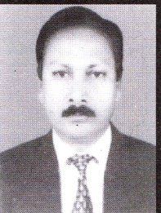 **Apex Club of CHANDPUR.**

Club # 10, District # 08

Organized : 26 Nov 1976

Founder President :

Apxn. Enayet Karim

Secrtary &

DNE

President

Founder Secretary :

Apxn. Mujibur Rahman Swapan

**Club History**

Apex club of Chandpur was formally inaugurate on 26 November 1976, Sponsored by Apex Club of Dhaka. The dub got its charter on 26 July 1977. Charter certificate was handed over by Apxn. Shahidullah NP. Apxn. Enayet Karim & Apxn. Mujibur Rahman, Swapan was the founder president & secretary respectvely

Jr. Vice President

Apxn. Adv. SM Nazimullah Bappy

Sp : Mrs. SamSunnahar Jashi

Pro : Lawyer

Ma : Judge Court, Chandpur

IN : 2016

BD : 31.12.1977

WD : 13.06.2010

BG : O(+)

Cell : 01727-743452

E-mail :

Sr. Vice President

Apxn. Md. Zahirul Hoque Miah

Sp : Kazi Pervin Hoque

Pro : Service

Ma : Judge Court, Chandpur

IN : 2010

BD : 01.02

WD : 30.06

BG : O(-)

Cell : 01714-438666

E-mail :

President

Apxn. Adv. Zakir Hossain Talukder Faisal

Sp : Khandaker Nargish Hai

Pro : Lawyer

Ma : Debpur, Chnadpur

IN : 2013

BD : 2, April

WD : 4, Jan/2001

BG : B(-)

Cell : 01712-262400

E-mail :

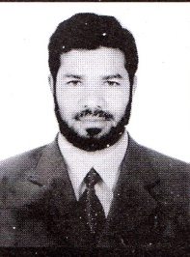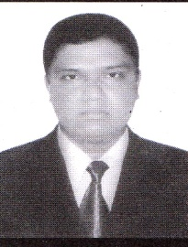

Secretary & DN Editor

Apxn. Adv. Md. Amran Hossain

Sp : Kamrun Nahar

Pro : Lawyer

Ma : Judge Court, Chandpur

IN : 2015

BD : 10.05.1973

WD : 25.06.1997

BG : B(+)

Cell : 01712-745936

E-mail :

IPP & Expansion Dirctor

Apxn. Adv.Jashim Uddin

Sp : Janntul Ferdousi Nitu

Pro : Lawyer

Ma : Muslim para, Comilla Road, Chandpur.

IN : 2006

BD : 12 Jun. 1979

WD : 7 Sept. 2007

BG : O(+)

Cell : 01716-230880

E-mail :

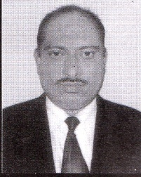

**Treasurer**

Apxn. Adv. Md. Abul kalam Azad

Sp : Rasheda Akter Ranu

Pro : Lawyer

Ma : Hossainpur, Ashrafpur,

Shahrasti, Chandpur

IN : 2015

BD : 01.01.1975

WD : 22.08.2002

BG : B(+)

Cell : 01819-176321

E-mail :

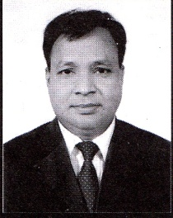

**Service Director**

Apxn. Adv. Dipak Chandra Debnath

Sp : Dulu Rani Debnath

Pro : Lawyer

Ma : Judge Court, Chandpur

IN : 2015

BD : 01.01.1976

WD : 04.03.2009

BG : B(+)

Cell : 01718-622627

E-mail :



**Membership & Attendance Director**

Apxn. Adv. Jashim Uddin Pradan

Sp : Mrs. Rabeya Akter Rumi

Pro : Lawyer

Ma : Judge Court, Chandpur

IN : 2015

BD : 01.03.1984

WD : 13.03.2012

BG : B(+)

Cell : 01833-850950

E-mail :

**Fellowship & Public Relation Dirctor**

Apxn. Md. Alamgir Hossain Prodhan

Sp : Tahamina Akter

Pro : Advocate Assistant

Ma : Judge Court, Chandpur

IN : 2015

BD : 23.03.1971

WD : 04.03.2007

BG : O (-)

Cell : 01813-339455

E-mail :



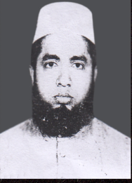

**Public Speaking & Debating Director**

Apxn. Md. Omar Faruque

Sp : Umma Salma

Pro : Service

Ma : Judge Court, Chandpur

IN : 2016

BD : 01.01.1987

WD : 22.10.2008

BG : O (+)

Cell : 01612-780212

E-mail : faruque326@gmalil.com



**Sergeant-At-Arms**

Apxn. Gonesh Sarker

Sp : Tanni Rani

Pro : L.Lawyar

Ma : Misson road, Chandpur

IN : 2015

BD : 05.01.1986

WD : 09.12.16

BG : B (+)

Cell : 01718-298950

E-mail :

**Floor Member :**

**Floor Member**

**Apxn. Adv. Ruhul Amin Sarker**

Sp : Halima Akter Rina

Pro : Lawyer

Ma : Adarsha Muslim para,

Comilla Road, Chandpur.

IN : 1994

BD : 15.05

WD : 16.08B

BG : O (+)

Cell : 01711-989321

E-mail :

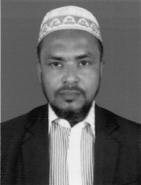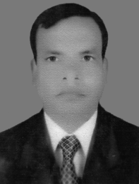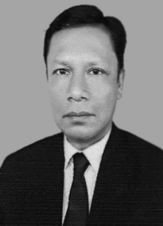



**Floor Member**

**Apxn. Adv. S.H.M Ayub Ali Chowdhury**

Sp : Unmarried

Pro : Lawyer

Ma : Holding no- 1124/1033, East Nazir para, Chandpur shadar, Chandpur.

IN : 2016

BD : 20 May 1975

WD : 10.05.2013

BG : B (+)

Cell : 01824-027447

E-mail :

**Floor Member**

**Apxn. Md. Zakir Hossain**

Sp : Nishat Ara Jannat

Pro : Lawyer

Ma : Holding no- 1388, Word no- 12

Back side of Eye Hospital, Comilla Road, Chandpur.

IN :2016

BD : Feb.02.1980

WD : 10.05.2013

BG : AB (+)

Cell : 01686-300300

E-mail :

**Floor Member**

**Apxn. Adv. Md. Salah Uddin Maizae**

Sp : Umme Johora

Pro : Lawyer

Ma : G.T Road, Chandpur.

IN :2016

BD : 01.01.1973

WD : 22.07.2007

BG : B (+)

Cell : 01818-849426

E-mail :

**Floor Member**

**Apxn. Adv. Md. Harun-Or-Rashid**

Sp : Farzana Islam

Pro : Lawyer

Ma : Adalat para, BT Road,

Hazi Mohsin Road, Chandpur

IN :2006

BD : 20.03.1976

WD : 25.03.2008

BG : B (+)

Cell : 01815-231095

E-mail :

**Floor Member**

**Apxn. Alhaz Md. Ibrahim Khalil Sarkar**

Sp : Mrs. Fathema Akter

Pro : Civil court Commissioner

Ma : Judge Court, Chandpur

IN :1996

BD : 04.01.1967

WD : 15.08.2003

BG : O(+)

Cell : 01821-215944

E-mail :

**Floor Member**

**Apxn. Adv. Abul Kashem**

Sp : Rowshan Ara Begum

Pro : Lawyer

Ma : Bishnudi, BT

Road, Sholaghar, Chandpur.

IN : 2008

BD : 10 Jan. 1964

WD : 7 Feb. 1988

BG : B (+)

Cell : 01711-701752

E-mail :

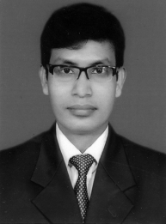

**Floor Member**

**Apxn. Md. Monzur Islam Talukder**

Sp : Samchurnahar

Pro : Service

Ma : Talukder Bari, Duttosholla, Foridgong, Chandpur.

IN : 2016

BD : 02 Mar 1980

WD : 03.02.2011

BG : A (+)

Cell : 01688-420101

E-mail :